ExNo:1 //JAVASCRIPT INTRO

PROGRAM:

<html>

<body>

<title>js intro</title>

<h2>java script used in body</h2>

<p id="s"></p>

<script>

document.getElementById("s").innerHTML = "java script was displayed ";

</script>

</body>

</html>

OUTPUT:

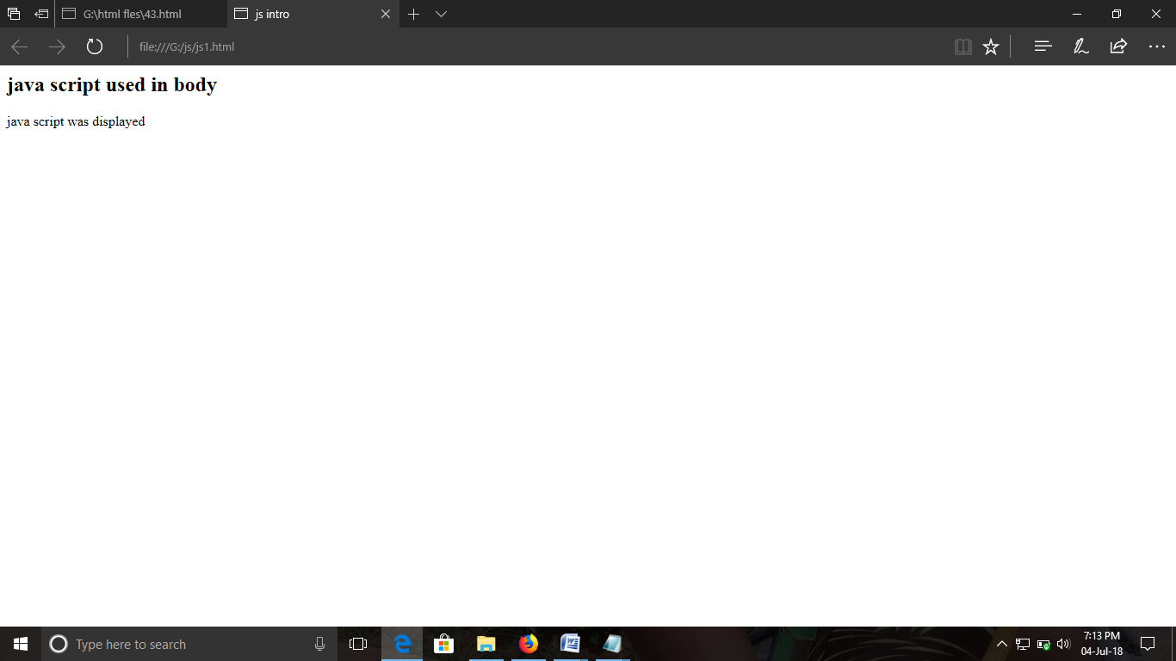

ExNo:2 //JAVASCRIPT LOCATION

PROGRAM:

<html>

<body>

<p><b>I M USING JAVA SCRIPT</b></p>

<button onclick="myFunction()">touch mee </button>

<script>

function myFunction()

{

alert("I M A POPUP MSG BOX");

}

</script>

</body>

</html>

OUTPUT:

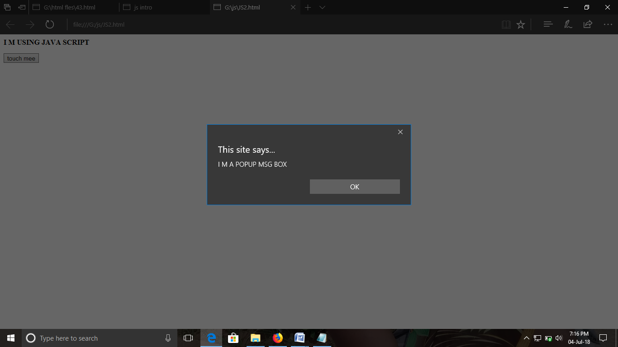

ExNo:3 //JAVASCRIPT EXTERNAL

PROGRAM:

<html>

<body>

<p><b>I M USING JAVA SCRIPT</b></p>

<button onclick="myFunction()">PLS CLICK </button>

<script src="js3b.js">

</script>

</body>

</html>

OUTPUT:

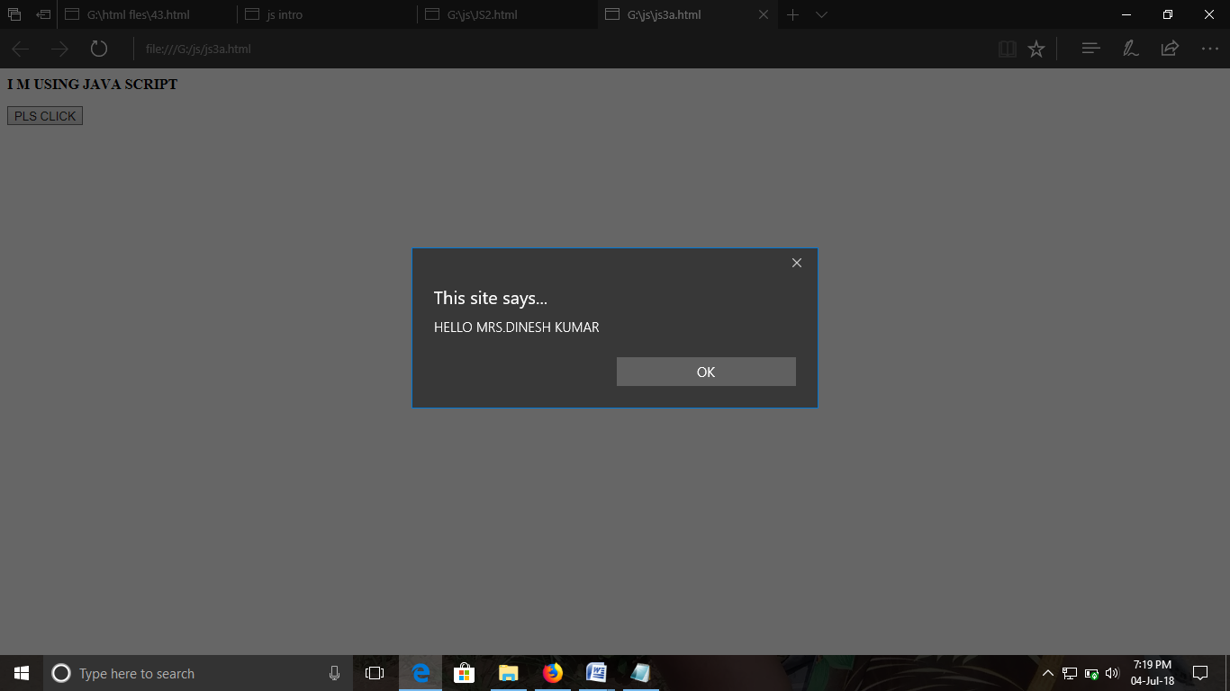

ExNo:4 //JAVASCRIPT OPERATOR

PROGRAM:

<html>

<body>

<p><b>I M EXECUTING JS OPERATOR</b></p>

<p id="dinesh"></p>

<script>

var txt1="DINESH";

var txt2="KUMAR";

document.getElementById("dinesh").innerHTML =txt1 +" " +txt2;

</script>

</body>

</html>

OUTPUT:

